Product Backlog



# **1. Product Backlog**

## **1.1. User Story Map**

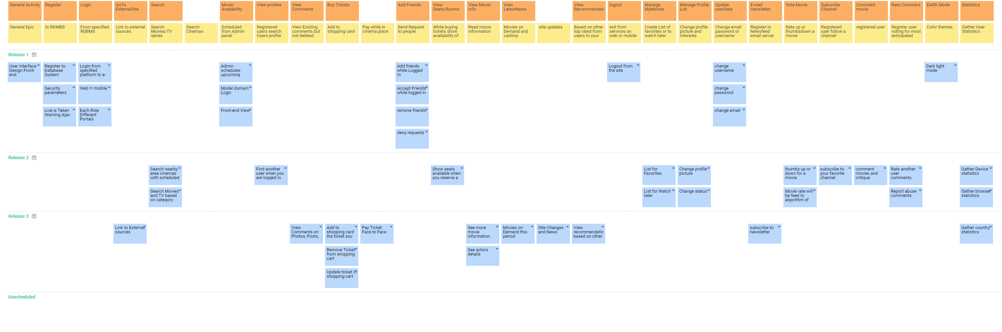

## **1.2. Prioritized User Stories**

| **ID** | **Name** | **Description** | **Epic** | **Status** | **Acceptance Criteria** | **Story Points** | **Priority** | **Risk** | **Split From** | **Due Date** |
| --- | --- | --- | --- | --- | --- | --- | --- | --- | --- | --- |
| US005 | Search nearby area cinemas with scheduled movies | As a user, I want to find available cinemas nearby of this scheduled movie so that I will enjoy it watching it with my friends | Search Movies/TV series | Approved |  | 5 | Must | High |  |  |
| US006 | Admin schedules upcoming Movies for Cinemas | As an Admin, I want to schedule movies for my customers/users so that popularity increases | Scheduled from Admin panel | Approved |  | 3 | Must | Medium |  |  |
| US007 | Find another user when you are logged in | As a User, I Wan to be socialized so that I will be famous | Registered users search Users profile from RDMS | Approved |  | 2 | Must | Low |  |  |
| US008 | View Comments on Photos, Posts, Videos | As a User, I want to entertain my self with other status updates so that I will know things in the community | View Existing comments but not deleted | Approved |  | 2 | Should | Low |  |  |
| US009 | Add to shopping card the ticket you reserved | As a User, I want to have an easy way on buying stuff so that everything will be organized | Add to shopping card | Approved |  | 3 | Should | Medium |  |  |
| US010 | Pay Ticket Face to Face | As a Site-Visitor or User, I want to be able to pay in front the check if no money on card is available. | Pay while in cinema place | Approved |  | 1 | Must | Low |  |  |
| US011 | Add friends while Logged in | As a User, I want to add people that I know in my Contact list for an easy chatting | Send Request to people | Approved |  | 2 | Must | Medium |  |  |
| US012 | Show seats available when you reserve a ticket | As a User/Site-Visitor, I want to know where are seat positions and which of them are available. | While buying tickets show availability of seats | Approved |  | 3 | Must | Medium |  |  |
| US013 | See more movie information based on what you choose | As a User/Site-Visitor, I want to know more details about each movie so that I will be informed technically. | Read movie information | Approved |  | 5 | Could | Low |  |  |
| US014 | Movies on Demand this period | As a User/Site-Visitor, I want to watch Top most demand movies/TV series every period. | Movies on Demand and casting | Approved |  | 5 | Should | Medium |  |  |
| US015 | Site Changes and News | As a User, I want to know every single site improvement. | site updates | Approved |  | 3 | Could | Low |  |  |
| US016 | View recommendation based on other users and your preference | As a User, I want to have an easy way to find best Movies/TV based on my vanilla flavor | Based on other top rated from users to your most viewed category | Approved |  | 5 | Should | Medium |  |  |
| US017 | Logout from the site | As a User, I want be able to exit from services | exit from services on web or mobile | Approved |  | 1 | Must | Low |  |  |
| US018 | List for Watch later | As a User, I want to have a watch later list | Create List of favorites or to watch later MOVIES/TV series | Approved |  | 3 | Should | Medium |  |  |
| US020 | Change profile picture | As a User, I want to change my Username so that I would be happy again | Change profile picture and interests | Approved |  | 2 | Should | Low |  |  |
| US021 | Change status | As a User, I want to change my Status | Change profile picture and interests | Approved |  | 1 | Should | Low |  |  |
| US022 | List for Favorites | As a User, I want to change my Username so that I would be happy again | Create List of favorites or to watch later MOVIES/TV series | Approved |  | 2 | Should | Medium |  |  |
| US023 | change username | As a User, I want to change my Username so that I would be happy again | Change email password or username | Approved |  | 1 | Should | Low |  |  |
| US024 | change password | As a User, I want to change my password regularly so that my account will not be compromised or any security leaks. | Change email password or username | Approved |  | 1 | Should | Low |  |  |
| US025 | change email | As a User, I will like to have the ability to change an e-mail address just in case. | Change email password or username | Approved |  | 1 | Should | Low |  |  |
| US026 | subscribe to newsletter | As a User, I want to Keep up with updates in my push or email notification List | Register to Newsfeed email server | Approved |  | 3 | Could | Medium |  |  |
| US027 | thumbs up or down for a movie | As a User, I want to Rate a movie so that other to know before watch | Rate up or thumbsdown a movie | Approved |  | 3 | Should | Medium |  |  |
| US028 | Movie rate will be feed to algorithm of recommendations | As a Customer, I want to change an easy way of recommending movies/TV if they are good | Rate up or thumbsdown a movie | Approved |  | 8 | Should | High |  |  |
| US029 | subscribe to your favorite channel | As a User, I want to change my Username so that I would be happy again | Registered user follow a channel | Approved |  | 3 | Should | Medium |  |  |
| US030 | comment movies and critique | As a User, I want to comment and leave a critique if a movie/TV was good | registered user | Approved |  | 3 | Should | Medium |  |  |
| US031 | Dark light mode | As a User, I want to allow my eyes to rest or see better on dark areas with different Color theme modes so that I would be happy with my eyes | Color themes | Approved |  | 1 | Must | Low |  |  |
| US032 | Rate another user comments | As a User/Customer, I want to distinct most anticipated comments so that others will see | Register user voting for most anticipated coment | Approved |  | 3 | Should | Medium |  |  |
| US033 | Report abuse comments | As a Customer/User/Site-Visitor, I want to have abuse FREE site sections because this is inappropriate for my eyes or any children lurking around | Register user voting for most anticipated coment | Approved |  | 3 | Must | Medium |  |  |
| US034 | Gather Device statistics | As a Customer, I want to know if my business going well | Gather User Statistics | Approved |  | 2 | Should | Low |  |  |
| US035 | Gather browser statistics | As a Customer, I want to know if my business going well | Gather User Statistics | Approved |  | 2 | Should | Low |  |  |
| US036 | Gather country statistics | As a Customer, I want to know if my business going well | Gather User Statistics | Approved |  | 2 | Should | Low |  |  |
| US038 | User Interface Design Front-end | As a Customer, I want to have a nice representation of Site so more people approach it or recommend it. | General Epic | Approved |  | 8 | Must | Low |  |  |
| US041 | Login from specified platform to e-Services | As a Programmer, I want to have distinct separation of portals that a customer/User logs in | From specified RDBMS | Approved |  | 2 | Must | Low |  |  |
| US042 | Link to External sources | As a User/Site-Visitor, I want to Have access to third party links for reviews or the creators of movies | Link to external sources | Approved |  | 1 | Could | Low |  |  |
| US043 | Search Movies and TV based on category | As a User/Site-Visitor, I want to Search for my Movies/TV's if I don't remember something about it. | Search Movies/TV series | Approved |  | 3 | Should | Medium |  |  |
| US045 | Register to Database System | As a Programmer, I want to have an organized status of Users for easy management and Today top tech solutions | to RDMBS | Approved |  | 1 | Must | Low |  |  |
| US046 | Security parameters | As a Programmer, I want to have sanity and security checks for Secure and happy clients. | to RDMBS | Approved |  | 1 | Must | Low |  |  |
| US047 | Live is Taken Warning Ajax | As a Programmer, I want to show to the User a message before he submits and not lose Precious time. | to RDMBS | Approved |  | 1 | Could | Low |  |  |
| US048 | Web != mobile | As a programmer, I want to have distinct portal logins based on device that a customer/User logs in | From specified RDBMS | Approved |  | 1 | Must | Low |  |  |
| US049 | Each Role Different Portals | As a programmer, I want to make distinct portal logins for clear and easy separations and future improvement of code. | From specified RDBMS | Approved |  | 1 | Must | Low |  |  |
| US050 | Model domain Logic | As an Admin, I want to have an easy way of organizing movies/shows/TV's | Scheduled from Admin panel | Approved |  | 3 | Must | Medium |  |  |
| US051 | Front-end View | As an Admin, I want to keep Live updated my Landing Page for any new Show/Movie | Scheduled from Admin panel | Approved |  | 2 | Must | Medium |  |  |
| US052 | Accept Friends while logged in | As a User, I want to Accept my Contacts. | Send Request to people | Approved |  | 2 | Must | Medium |  |  |
| US053 | remove friends | As a User, I want to be able to remove friends from list for personal reasons. | Send Request to people | Approved |  | 3 | Must | Medium |  |  |
| US054 | deny requests | As a User, I want to deny Friend requests that I don't know from unknown people | Send Request to people | Approved |  | 3 | Must | Medium |  |  |
| US055 | See actors details | As a User/Site-Visitor, I want to know more about casting and actors of each movie. | Read movie information | Approved |  | 1 | Could | Low |  |  |
| US056 | Remove Ticket from shopping cart | As a User, I want to Cancel a ticket if I accidentally or for some other reasons add it to List. | Add to shopping card | Approved |  | 3 | Should | Low |  |  |
| US057 | Update ticket in shopping cart | As a User, I want to Change a ticket if I changed my mind. | Add to shopping card | Approved |  | 3 | Should | Low |  |  |